****ALCA TECH Penetration Report

On Adobe Systems

TABLE OF CONTENTS

Executive Summary……………………..3

Reconnaissance……………………..4

Port Scanning……………………..5

Wireshark Sniffing……………………..5

Access to Server and PC……………………..6

Establishing a Connection……………………..8

Redirecting Traffic……………………..10

Training Program……………………..11

DoS Attack……………………..12

Key-Logging……………………..12

Web Server Attack……………………..13

Final Results……………………..13

Executive Summary

Foster’s company has decided to run a network penetration test on Adobe Systems. This test was created to test their network with various new exploits and attacks. These methods will eventually spot out vulnerabilities that could lead to serious infiltration by hackers or a malicious user. We will be testing both the internal and external forces of the network and have the results as soon as possible

Results

Below I will show you will continue to read on the results conducted during this penetration test on Adobe systems.

Target: Adobe Systems

**Background information on Adobe**

In the mid-1990’s and onwards, Adobe authored a number of products with its growing expansion of customer solutions and acquired technologies. Today, Adobe provides a number of quality software, both desktop and mobile, for creatives, developers and enterprises. Among their software solutions we have Acrobat XI, Dreamweaver CC, Photoshop, Illustrator, InDesign, and many other products for video editing, website and app design, cinematic visual effects, game design, etc. Adobe’s major acquisitions, which include Aldus (1994), GoLive (1999), Fotiva (2001), Accelio (2002), Macromedia, Inc. (2005), Scene7 (2007), Business Catalyst (2009), and one of the most recent ones, Behance Inc. (2012), have all contributed to the advanced versatility contained in its flagship products.

In addition, the company has also gone through internal changes. In 2000/2001, Warnock and Geschke, co-founders of the growing 18-year old company, retired and assumed the positions of co-chairmen of the board. After their retirement and until 2008, Adobe has been under the leadership of CEO Bruce Chizen. In 2002, he successfully led the company through the marketing and financial transition of providing enterprise platform technology, in addition to its already popular desktop software.

On the community level, Adobe continues to develop and support user groups, forums and communities on their website that use and share in the same technologies. Designers, developers, users, educators and partners—Adobe continues to design and develop with the end user in mind and for the community of users it has built.

Although based in San Jose, California, Adobe is also an international success. The company has several office branches in each of Europe, Asia, South America, and in Australia. Their Reader software has been translated into more than 26 languages, and comes preinstalled on PCs made by the top ten computer manufacturers in the world.

Charles Geschke and John Warnock created not only a company in 1982, they created an industry. Undeniably, their vision for graphics and publishing has permanently changed the way in which people communicate and create on a digital level.

Reconnaissance

Here’s an Nslookup command of adobe.com so that I can find out their IP Address

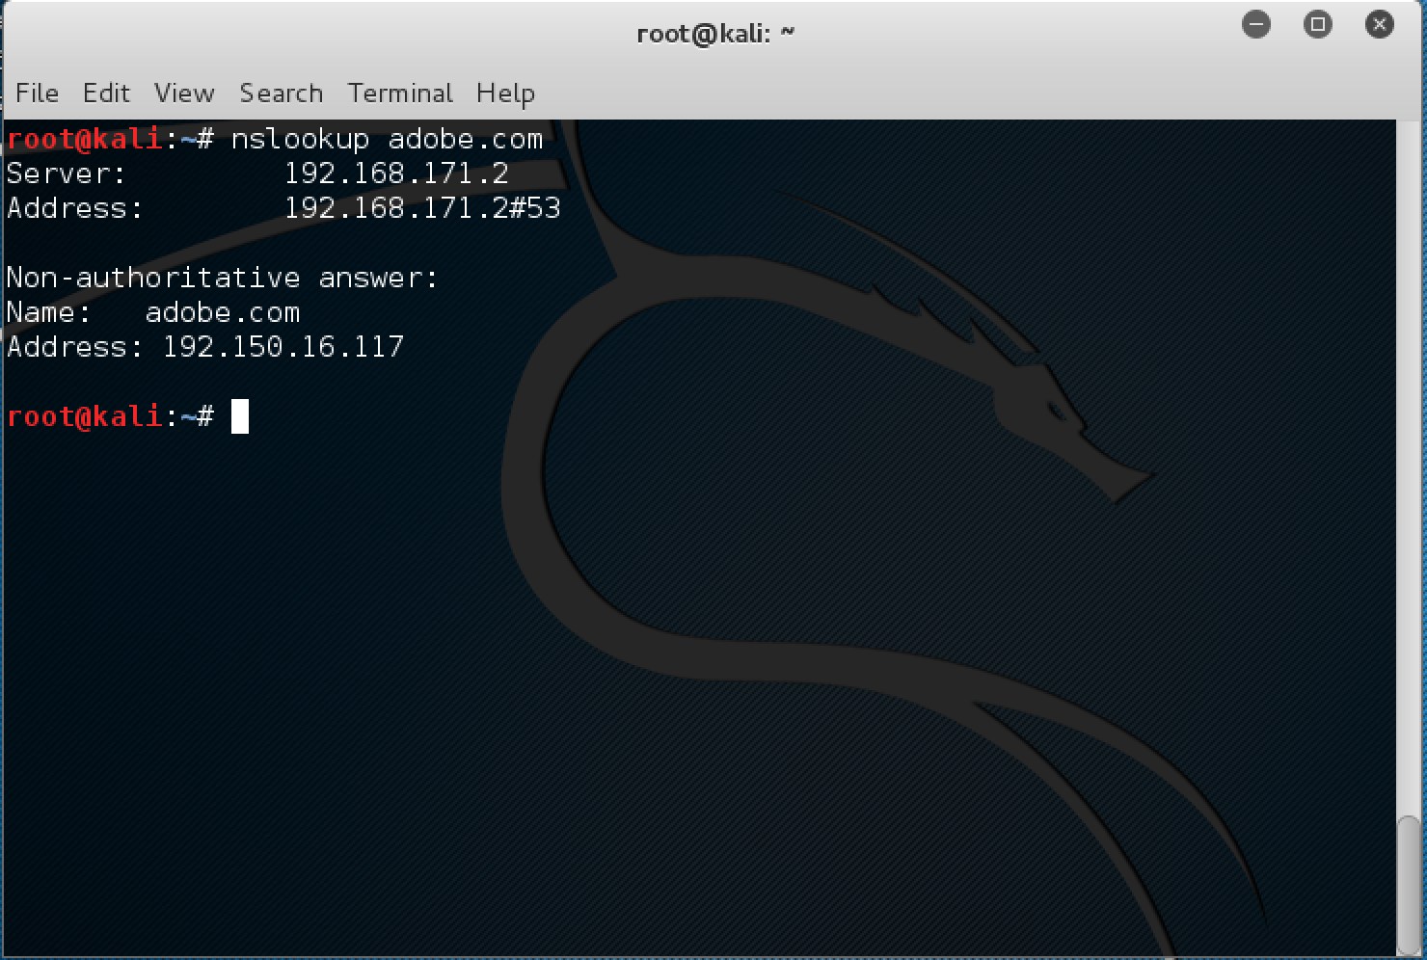

I went and did a dns search on the three additional sites on adobe systems, but there was nothing extra other than an extra email server that was found on the search. There isn’t much on the website that is new that I haven’t already found. As far as what would be useful for a hacker, the email service is a great and useful thing to know. A hacker would now know what service the organization is using in order to stop their messages. A denial of service attack could be conducted.

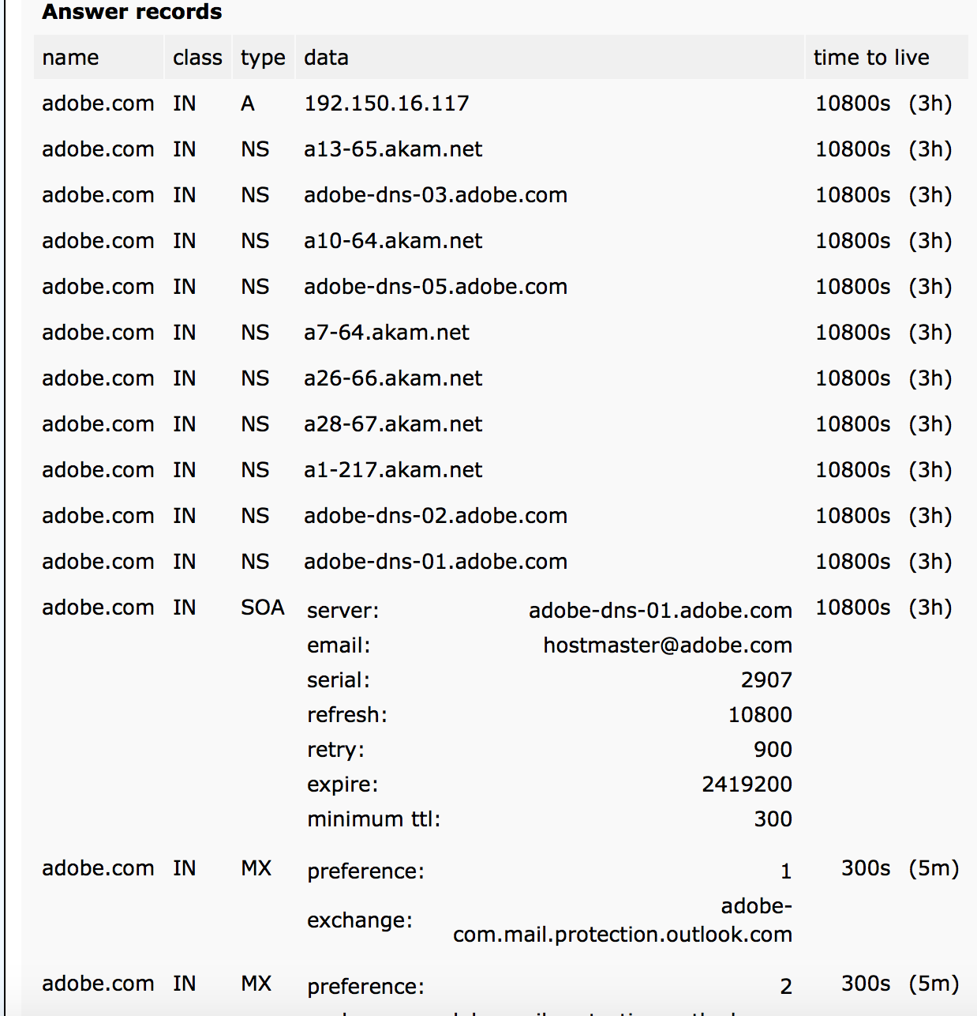

WHOIS Search

Port Scanning

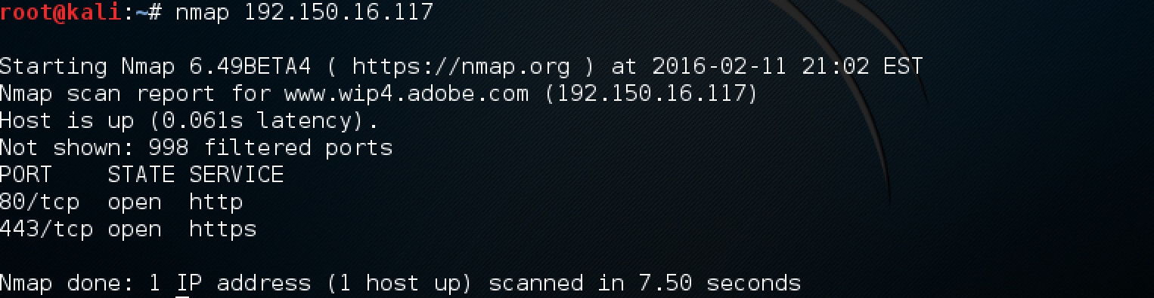

Here is my nmap scan of Adobe systems. The only ports that are open are the Internet ports, 80 and 443. Http and Https. I also did a stealth scan along with a fingerprint scan and received the same results. These are their only 2 ports that are open. This is great for their organization because a hacker is now limited to using a select amount of exploits that are known to gain access.

Wireshark Sniffing

Below is a screen shot of an employee from adobe systems trying to telnet to his office from home. We were just in time to catch the session and gain the username and password with Wireshark. As you can see Telnet is not secure and does not encrypt their passwords. We recommend using another form of SSH.

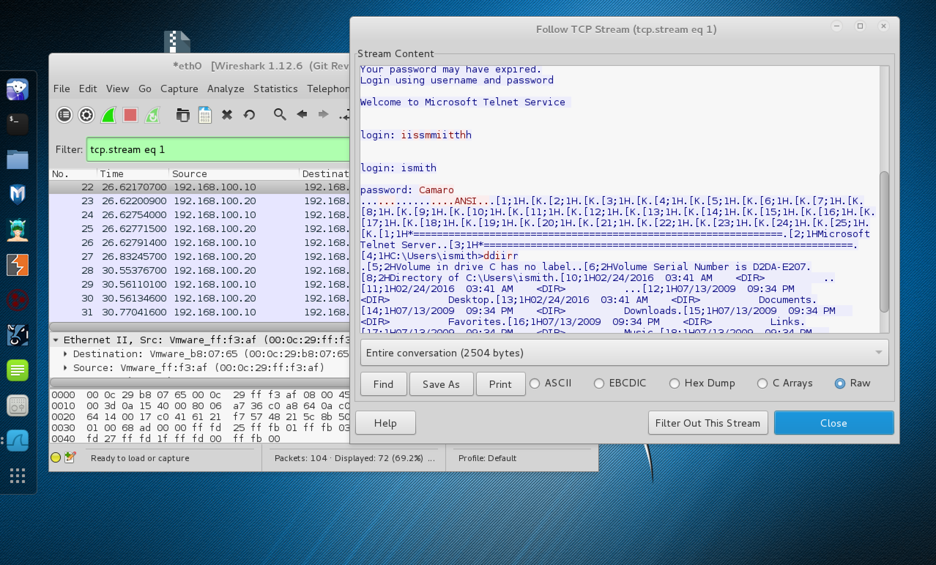

Access to Server and PC

Below is a screen shot of an employee desktop computer asking us to input a password. We are going to attempt to access his Desktop with the use of social engineering and a System rescue CD we just so happen to have if we were an attacker.

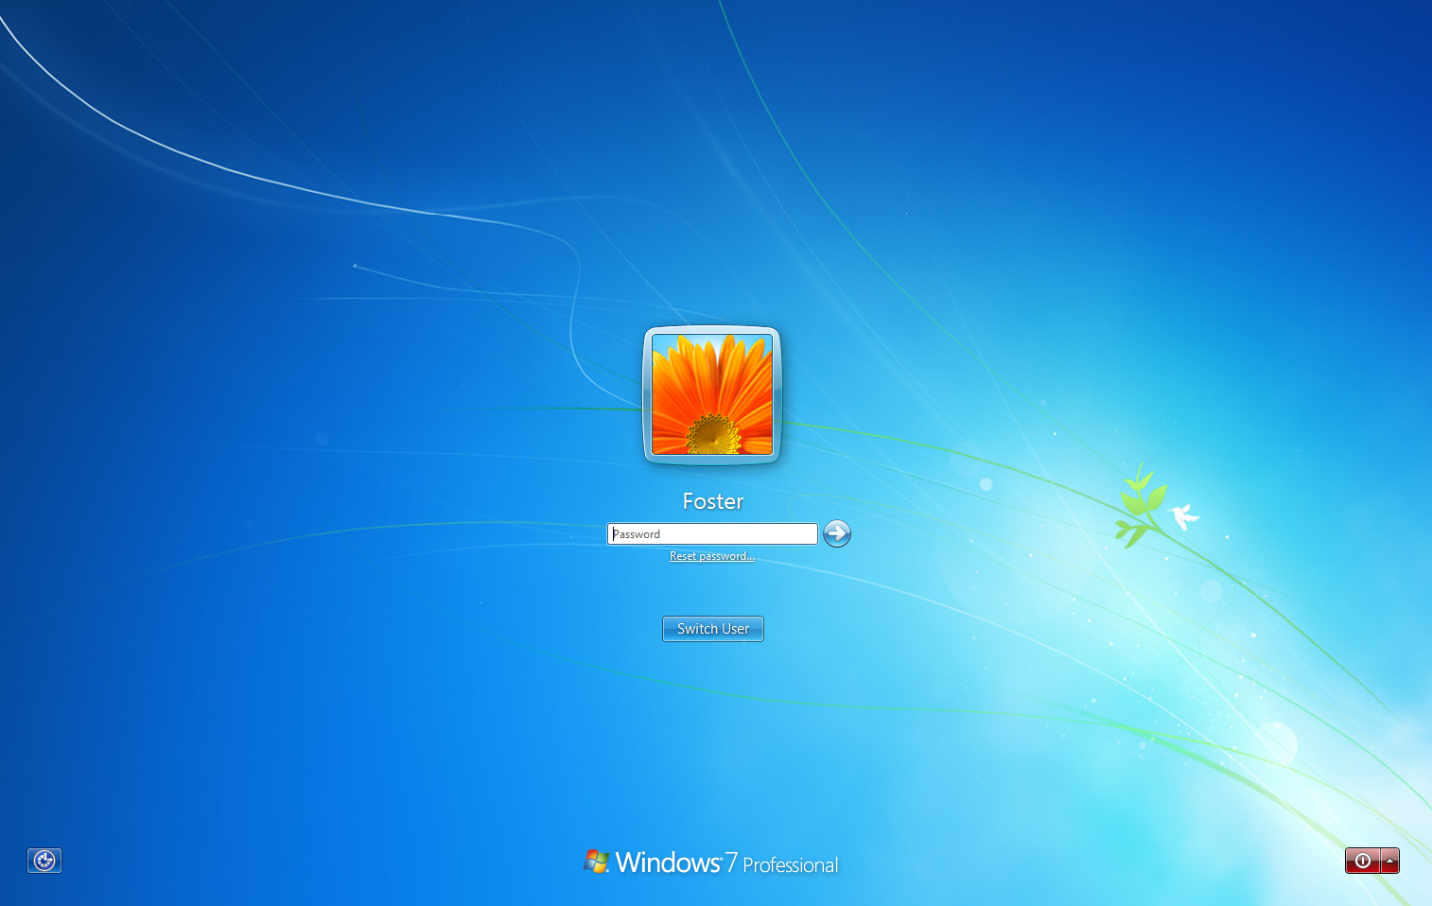

We inserted the Cd and began the process of entering the Employee Desktop. We decided to just delete the password completely. I booted up the password editor and began the process. I cleared the password, ejected the Cd and restated the system and had full access to the system.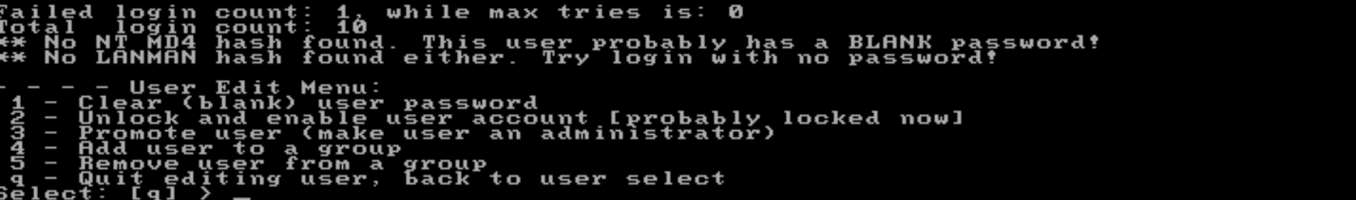

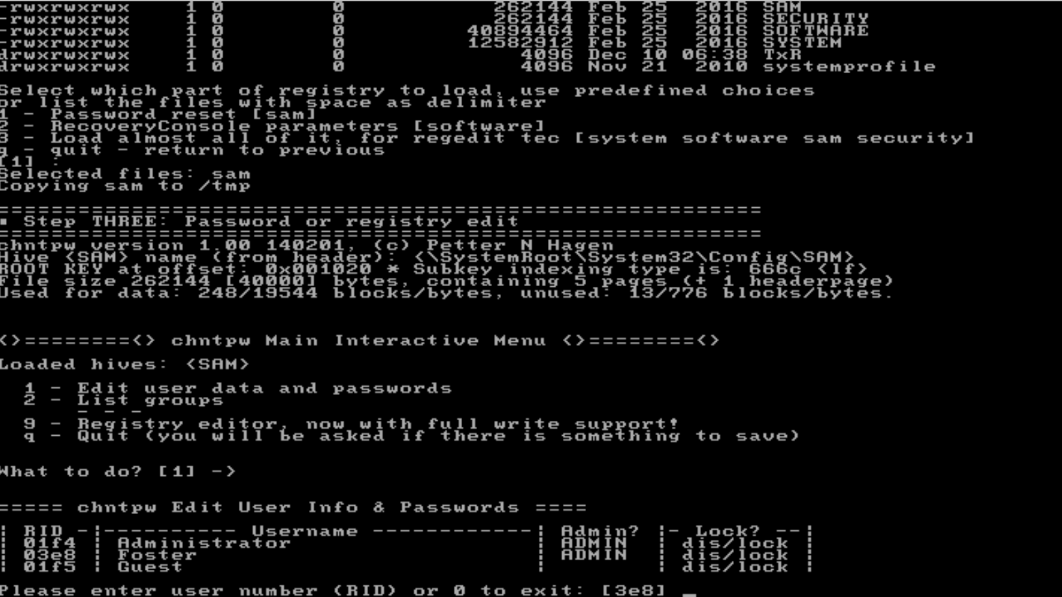

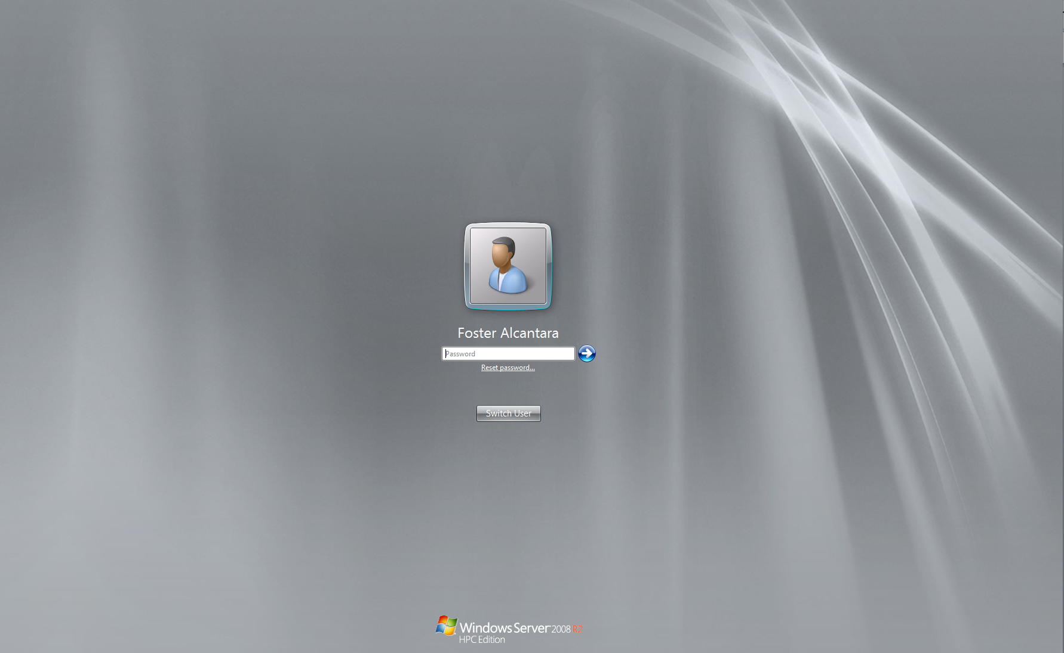Below is a screen shot of the Adobe System web server login page. We are going to attempt to access the server with the use of social engineering and a System rescue CD we just so happen to have if we were an attacker.

We inserted the Cd and began the process of entering the Server. We decided to just delete the password completely. I booted up the password editor and began the process. I cleared the password, ejected the Cd and restated the system and had full access to the system.

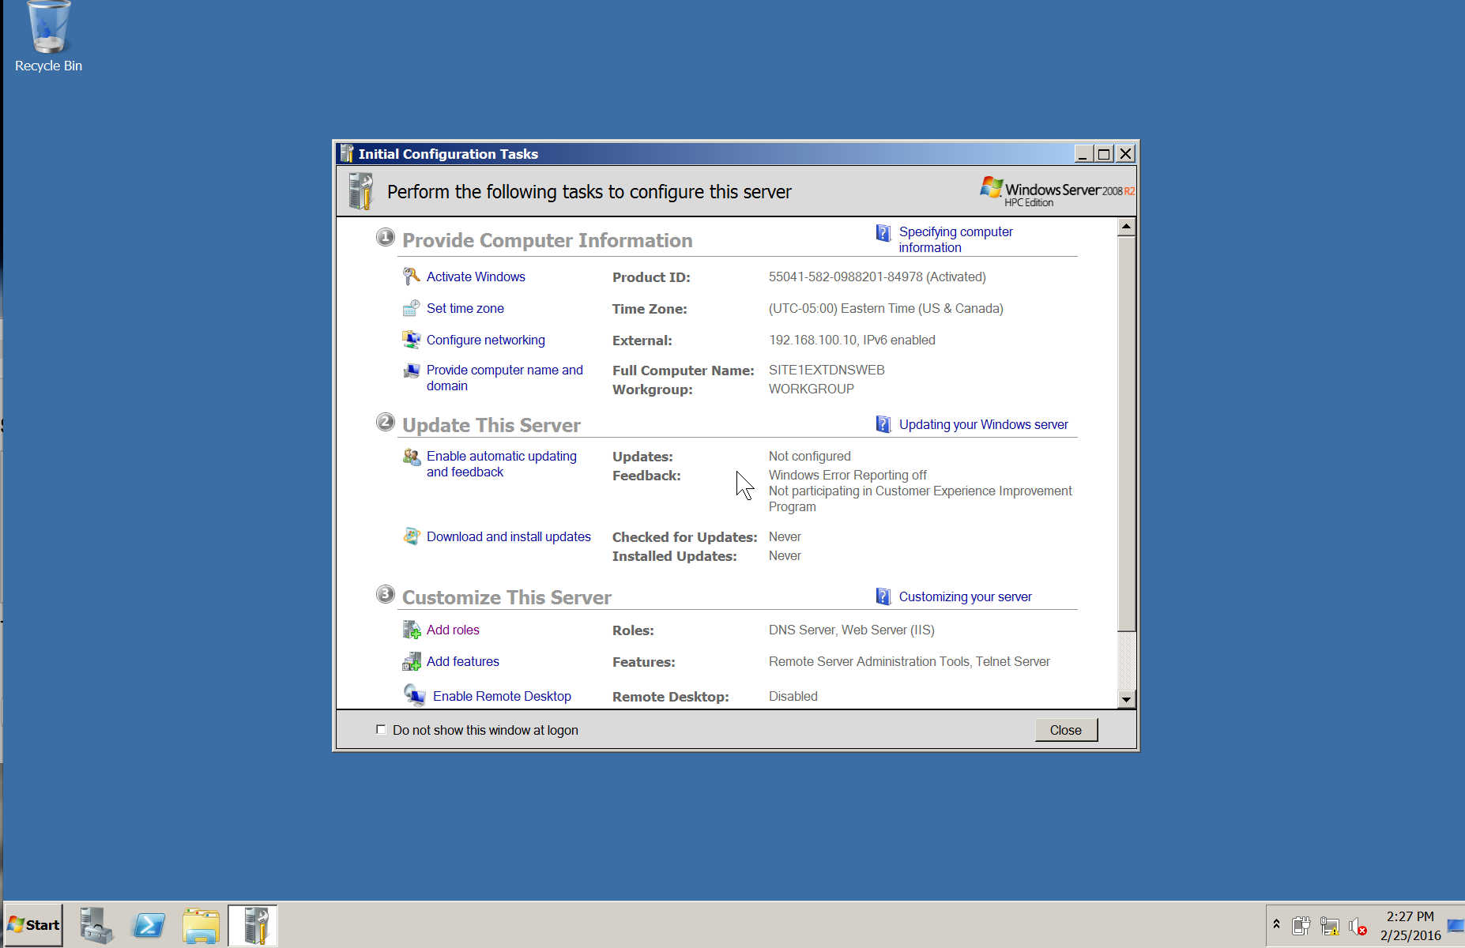

Establishing a Connection

In order for us to capture a connection session or a session already in place we need to sniff packets. In order for us to sniff packets we use a sniffer tool called Wireshark. There are other sniffer tools so don’t just limit yourself to one. All of them pretty much work the same way. There is a process called a 3-way handshake when establishing a connection. The TCP 3 way handshake is when 2 hosts want to communicate with each other. Host A sends Host B a packet wanting to communicate, Host B then returns the packet with a SYN, finally Host A acknowledges that Host B would like to communicate as well so Host A sends a third packet.

**An explanation describing how a hacker could use the vulnerabilities in TCP/IP to facilitate IP Spoofing, a connection hijacking, and a TCP?SYN Attack**

**Ip Spoofing**- A hacker could establish a tcp connection using a man in the middle attack and from there use source routing.

**Connection hijacking**- A hacker desynchronizes packets, and then sends the packets to the victim and if the victim accepts the packet the connection has been high jacked.

**TCP/SYN**- A hacker takes advantage of a three-way handshake in session and starts a syn flood by sending massive amounts of syn flags.

**A description of some steps that could be taken by the client to protect against these types of attacks**

* Modify the default timer values to disrupt or avoid TCP SYN attacks.
* Increase the number of simultaneous connections a computer can handle.
* Reduce the time limit for listening for replies to the SYN/ACK in the three-way  handshake.
* Change the method used to generate sequence numbers to make sequence guessing more challenging. Use a random number generator (RNG) to create part of the algorithm that arrives at the ISN.
* Implement firewall rules to block spoofed packets from entering the intranet through the Internet or vice versa.

EXAMPLE OF CAPTURING 3-WAY HANDSHAKE

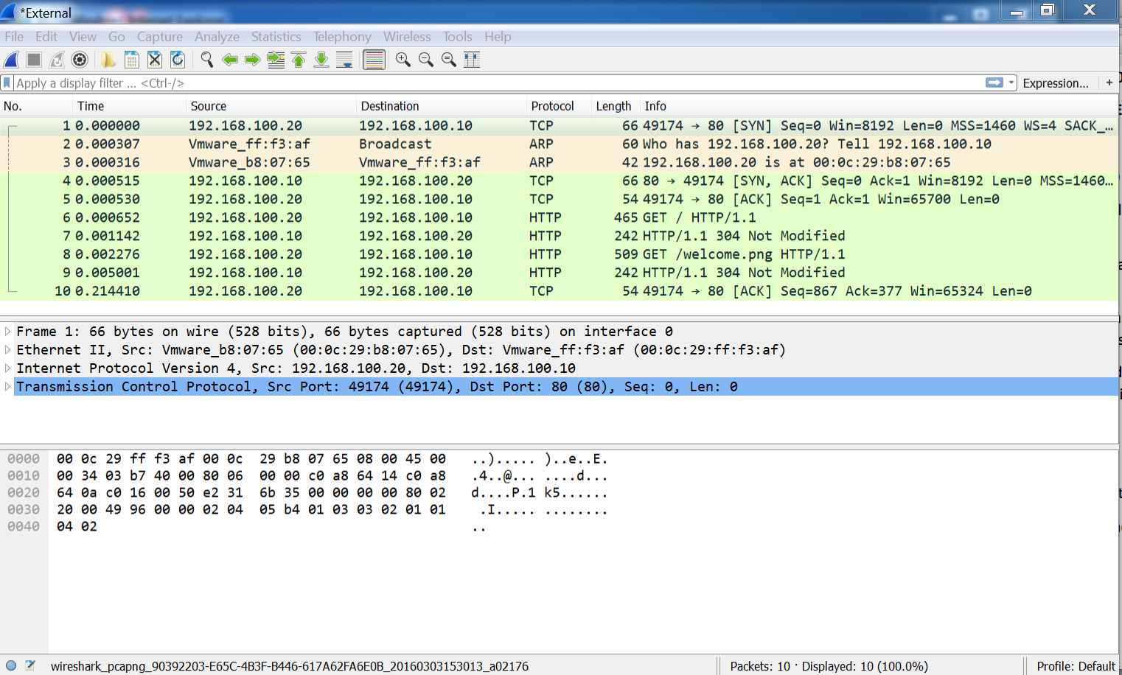

Redirecting Traffic

There are three main ways to redirect traffic from a box without changing much on the box itself. These modifications include those of: the host file, route table, and arp cache. Below you can find out more about each method and what to do to prevent this from happening.

**What is a Host File?**

The host’s file is a computer file used by an operating system to map hostnames to IP addresses. The host’s file is a plain text file, and is conventionally named hosts.

Editing the host file so that when I type [www.mybank.com](http://www.mybank.com) it will redirect to my web server page.

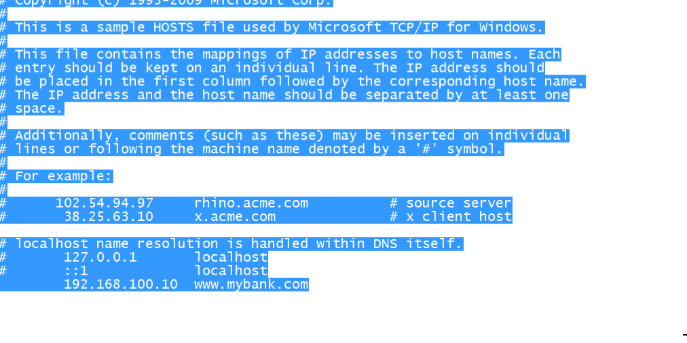

When I enter [www.mybank.com](http://www.mybank.com) I am redirected to the web server page.

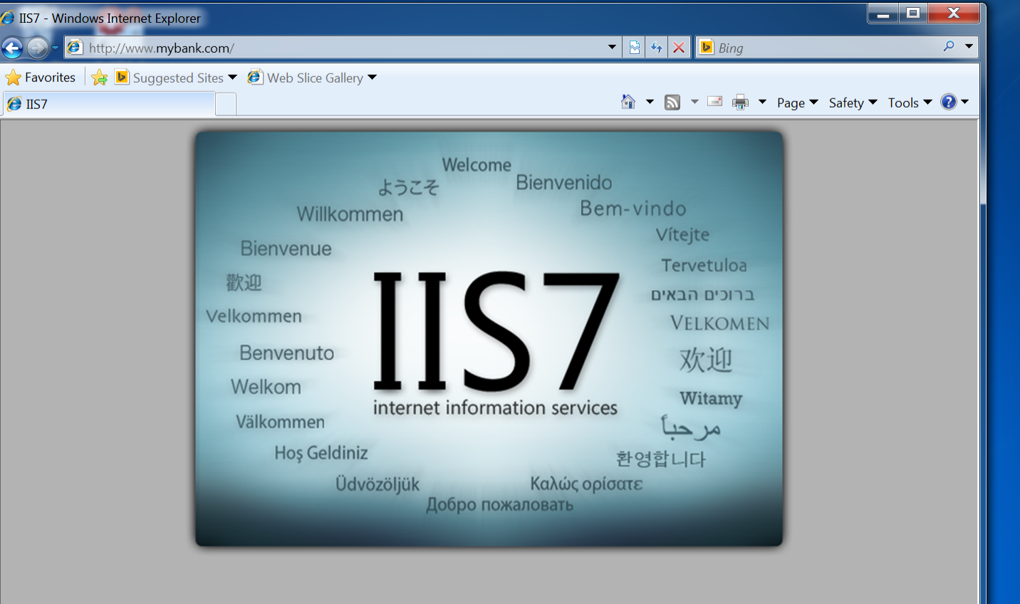

What is Route Table?

A routing table is a set of rules, often viewed in table format that is used to determine where data packets traveling over an Internet Protocol (IP) network will be directed. All IP-enabled devices, including routers and switches.

Another way to redirect traffic

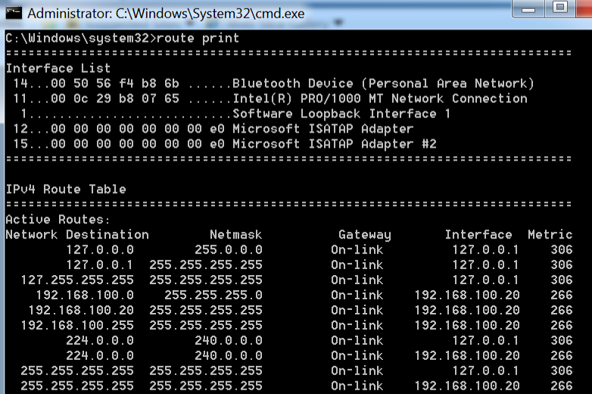

Training Program

**Target**: Adobe Systems

**Need**: Users need to know if a file is safe to download.

**Objective**: The user will know how to identify if a file is harmful to their PC.

**Implementation**: Their discussion on free software that will quickly scan a file you have downloaded it before you open it. Examples on how to scan and which software you should download. In total this training should take about an hour to an hour and 30 minutes.

In order to prepare the company for this training program, a memo along with an email will be sent out to all employees. The text will say “Mandatory” because it’s important to keep company assets safe but as well your own personal assets. This document is a 2 weeks’ notice of a mandatory training program that all employees will attend. The company will assign 5 of their best IT staff to carry out this program. Each staff member will carry out the task of leading the program and teach the rest of the employees. They will be required to create a lesson plan, pre-test and standardized test in order to test the employees’ prior knowledge to the subject and new. If an employee fails, he or she will be required to take the program again along with the tests until the pass with an 80 or above. The tests will be 20 questions all multiple choice based on everything that was discussed in the program.

DOS Attacks

What is a DoS attack?

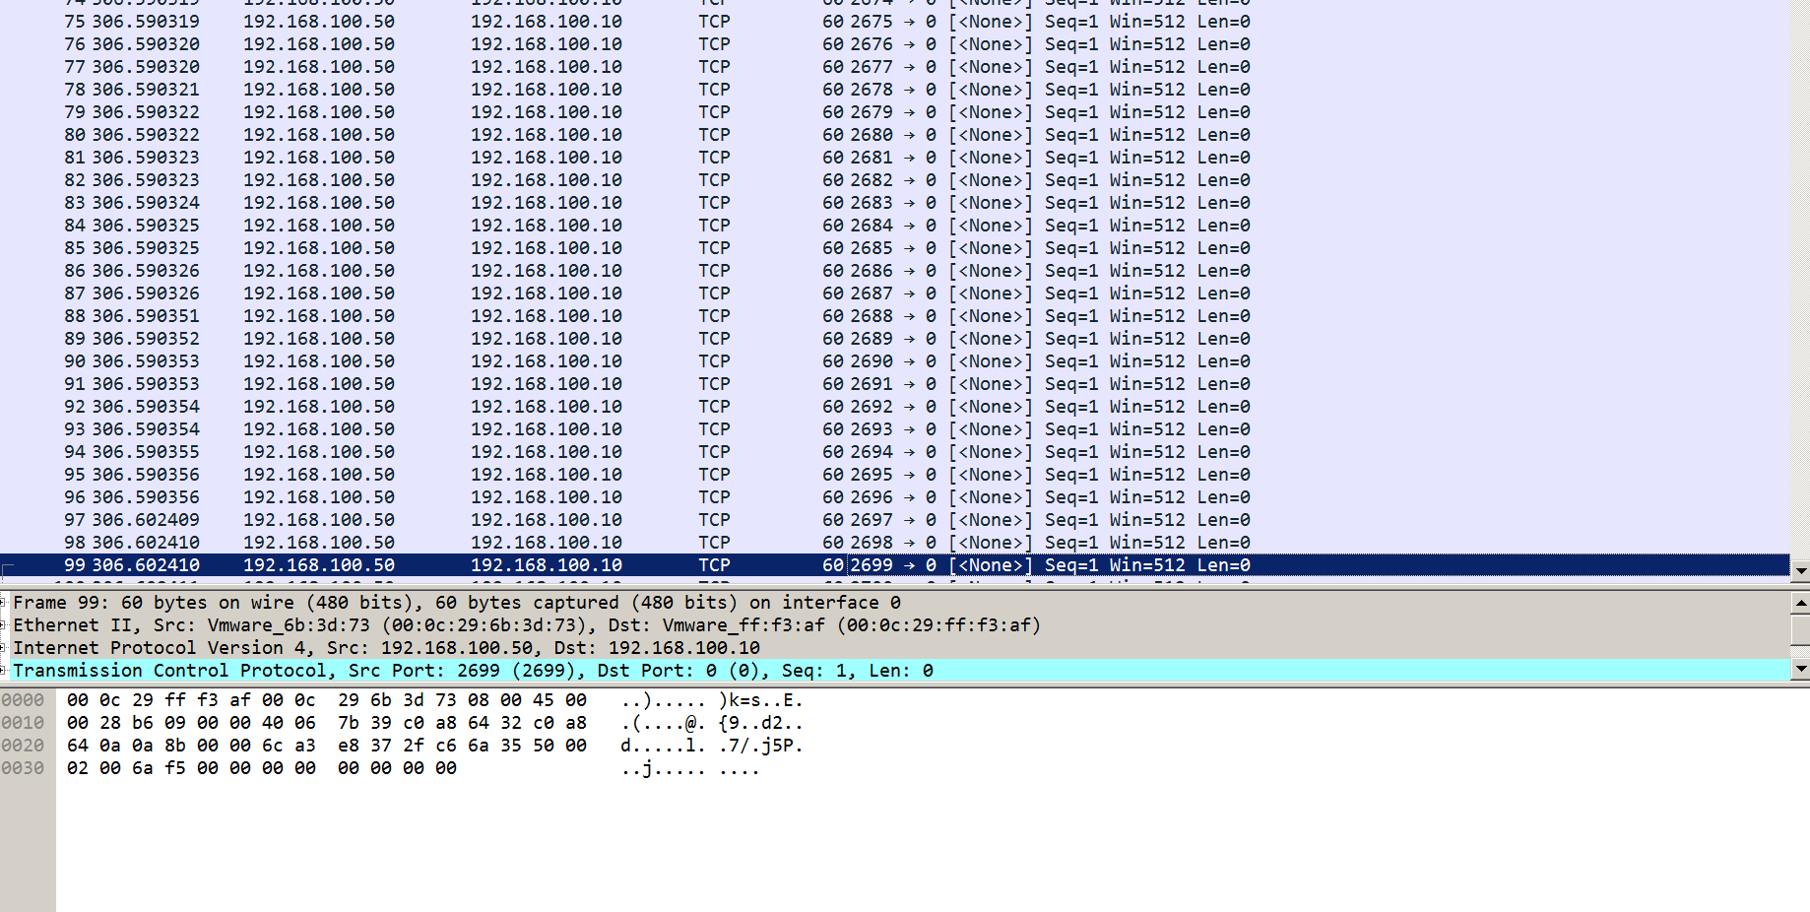In computing, a denial-of-service (DoS) attack is an attempt to make a machine or network resource unavailable to its intended users, such as to temporarily or indefinitely interrupt or suspend services of a host connected to the Internet. We managed to perform a DoS attack on Adobe System’s web server. We conducting a full packet flood along with a Syn flood.

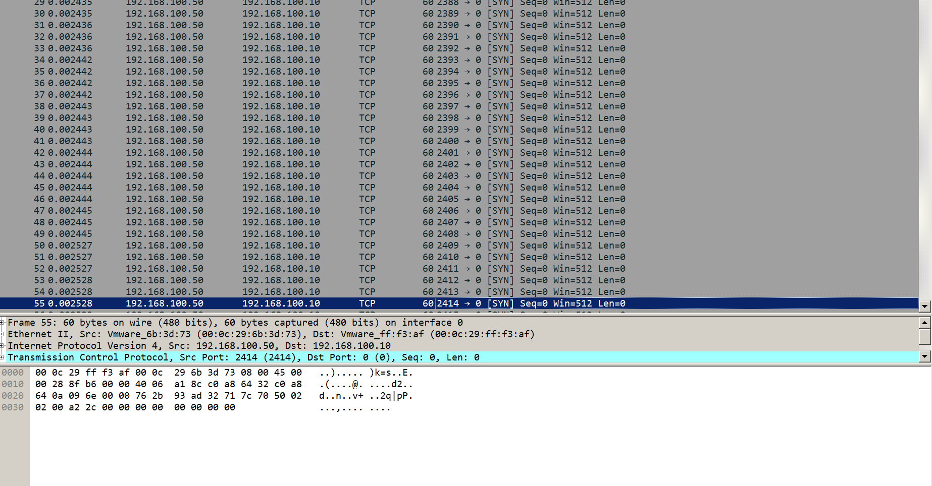

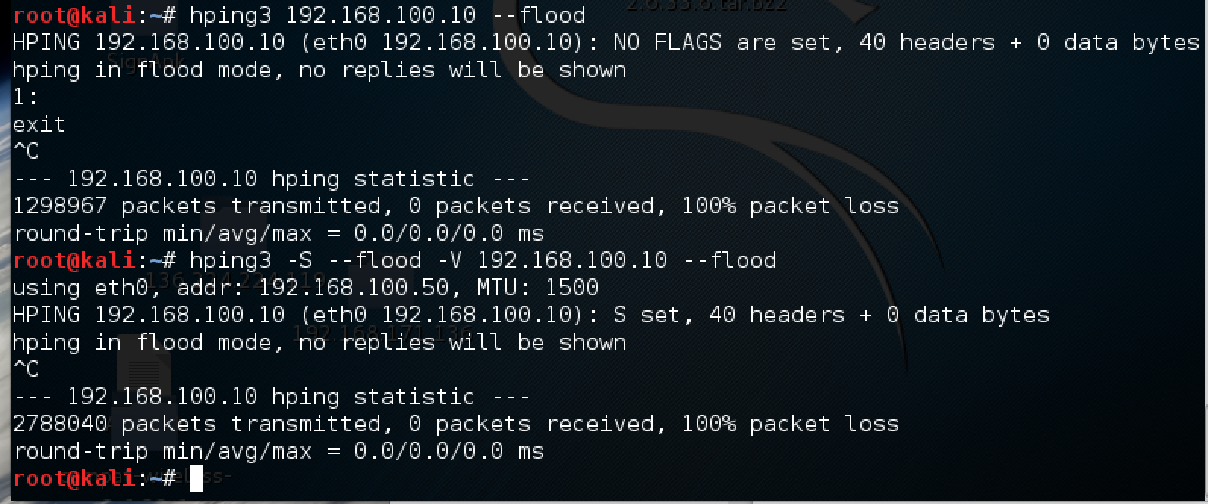Here are the tools and commands we used in order to conduct both of the attacks. We used kali Linux in order to conduct this.

Key-Logging

What is Key-Logging?

The use of a computer program to record every keystroke made by a computer user, especially in order to gain fraudulent access to passwords and other confidential information. I tried to put a Key logger on an employees Desktop but was unsuccessful.

Web Server Attack

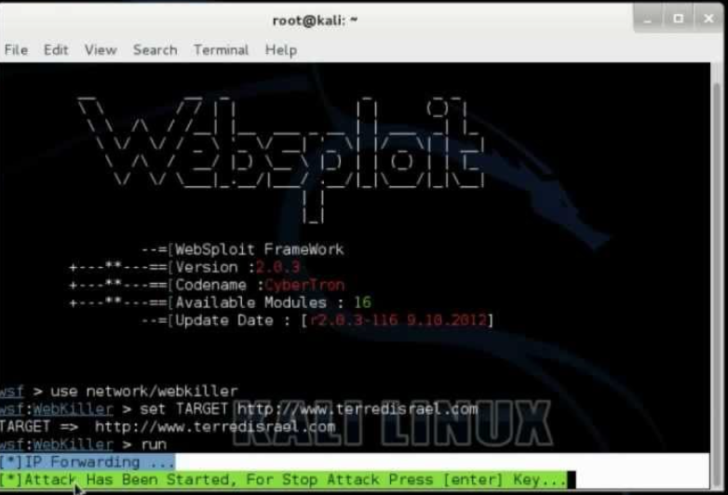

What is Websploit?

Websploit is an application on Kali Linux that hackers use in order to exploit or deface a web server. We ran an attack with Websploit on the company web server and it managed to be unsuccessful which is great news for Adobe System. It was great news for them to hear that

End Result

We have resulted that Adobe Systems has a healthy system, and a strong web server. Their employees need to stay away from social engineering and protect their personal systems in the company.